Trading System Diversity by John Slauson
I enjoy diversity. America is a diverse country. It is founded on principles that ensure diversity thrives. Diversity of people, culture, religion, and landscape are what make America great. It may be surprising to some that the state I live in, Utah, is quite diverse. From lush evergreen and alpine canyons, to the red rock arches, to the salty flats of Bonneville, the scenery quickly changes. And perhaps one of the best-kept secrets is the growing diversity of its people. The dominant religion in Utah attracts people from all over the world. My guess is that after the 2002 Winter Games conclude here, the secret will be out.
Diversity provides checks and balances. The opposition between Democrats and Republicans in the our political system provides increased economic and social stability. Diversity in a trading system is also important, but it comes wrapped with a more "sophisticated" sounding name introduced shortly. I’ve recently been facilitating the development of a customized trading system for a client. I say "facilitating" because I’m convinced that the absolute best trading systems are those that evolve from the mind of the trader. My job is to start and nurture this evolutionary process.
Most people choose to build their trading system using components with which they are familiar. This is not a problem, as long as the components are diverse. For example, a trading system comprised only of Stochastics and RSI will not produce consistent results over the long-term since both indicators measure the same property, price momentum. John Bollinger often refers to this trading system requirement as "noncollinear"—meaning that a "robust" trading system has few similar or overlapping components.
In geometry, "noncollinear" is generally defined as three points that are not in a straight line (i.e., the resulting line connecting the three points is not linear). The best trading systems are developed using the same requirement. The table below is a simple illustration of this. I’ve divided nine popular indicators into three categories: momentum, market strength, and volatility. The category names relate to the property measured by the indicator.
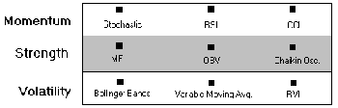
For unknown reasons, momentum indicators seem to dominate the landscape. I find that too many trading systems are built on this one category of indicator. It’s not unlike a weatherman with a room full of sophisticated measuring instruments, habitually using only the three different brands of barometers sitting on the back table to come up with his forecast. Sure, each barometer gives slightly different readings, but each measures the same atmospheric condition, barometric pressure. A technical analyst using a trading system comprised of three "brands" of the same instrument is more likely to forecast "warm and sunny" when "damp and cold" is the outcome.
The tables below illustrate how nine indicators can be combined to create a trading system. A bad system (i.e. one that is comprised of collinear components) is illustrated in Table A. Stochastic, RSI, and CCI are used to measure a security’s momentum. A system that contains all three is simply measuring momentum three different ways—not very robust. The system in Table B is better, since it incorporates a market strength component (i.e., OBV) in addition to the two momentum components (i.e., Stochastic and CCI). However, a system comprised of the components in Table C is most likely to perform well. It contains components from each category—Stochastic for momentum, OBV for market strength, and Bollinger Bands for Volatility.
Table A: Bad Trading System (Collinear)
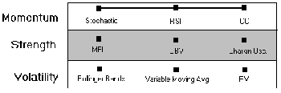
Table B: Fair Trading System (modestly noncollinear) 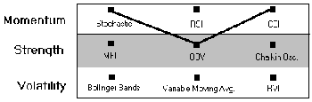
Table C: Good Trading System (noncollinear) 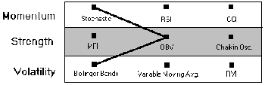
From these nine indicators, there are 27 noncollinear combinations, and only 3 collinear combinations. If a monkey were to pull three indicators from a bag containing all nine, the odds favor Bonzo coming up with at least two of the three categories covered. But for some reason, we human animals are inflicted with a terrible trading disease called momentumitis.
Fortunately there is a cure. But remember…it’s noncollinear.

