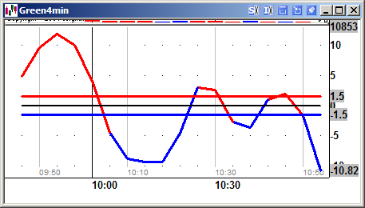

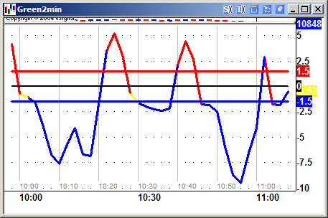

/*********************************************************
Market 10 minute intervals - shift click to move up
**********************************************************/

function preMain() {
setPriceStudy(false);
setStudyTitle("Time Marker 10");
setCursorLabelName("Time");
setShowTitleParameters(false);
checkVersion(6,"http://share.esignal.com/ContentRoot/ACM%20Test/Formulas/Time Marker.efs");

var fp1 = new FunctionParameter("Interval", FunctionParameter.NUMBER);
fp1.setLowerLimit(0);
fp1.setDefault(10); //Edit this value to set a new default

var fp2 = new FunctionParameter("Offset", FunctionParameter.NUMBER);
fp2.setDefault(0); //Edit this value to set a new default

var fp3 = new FunctionParameter("Lines", FunctionParameter.STRING);
fp3.addOption("On");
fp3.addOption("Off");
fp3.setDefault("On"); //Edit this value to set a new default

var fp3a = new FunctionParameter("Time", FunctionParameter.STRING);
fp3a.addOption("On");
fp3a.addOption("Off");
fp3a.setDefault("On"); //Edit this value to set a new default

var fp4 = new FunctionParameter("Cursor", FunctionParameter.STRING);
fp4.addOption("false");
fp4.addOption("true");
fp4.setDefault("true"); //Edit this value to set a new default

}

var Cntr = 0;
var x;
var y;
var z;

function main(Interval,Offset,Lines,Time,Cursor){

setShowCursorLabel(eval(Cursor));

if(isDWM()==true){
setShowCursorLabel(false);
return;
}

if(getBarState()==BARSTATE_NEWBAR){
Cntr += 1;
}

x = (getHour()*1)+Offset;
y = getMinute()*1;

if(x>=24) x = x-24;
if(x<0) x = 24+x;
if(x<10) x = "0"+x;
if(y<10) y = "0"+y;

z = x+":"+y;

if((getMinute()/Interval) == Math.floor(getMinute()/Interval)){
if(Time=="On"){
drawTextRelative(0,0,z,Color.grey,null,Text.RELATIVETOBOTTOM,"Arial",10,"Time2"+Cntr);
}
if(Lines=="On"){
drawLineRelative(0,-20,0,99999,PS_SOLID, 1, Color.lightgrey,"Time"+Cntr);
}
}

return z+"";
}

